|  |
| --- |
| **National University of Computer and Emerging Sciences** |
| In-Lab 5 Exercise  “Nested Queries” |
|  |
| Database Systems |
| Spring 2021 |

Department of Computer Science

FAST-NU, Lahore, Pakistan

**Schema:**

For this exercise use the following schema, the script to create this schema and populate data is given in Twitter.SQL file.

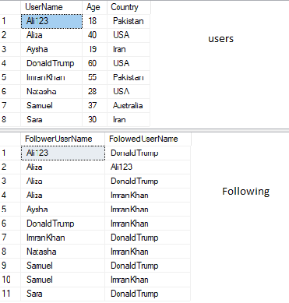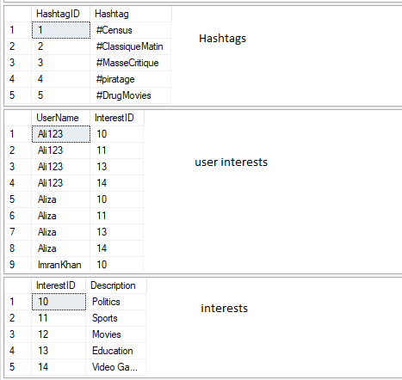

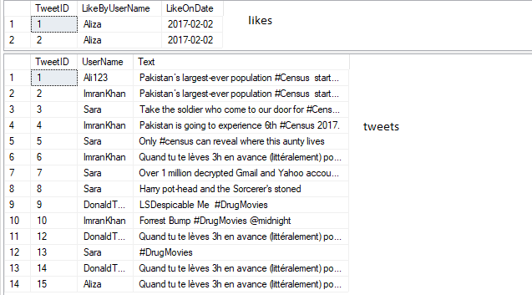

**Exercise:**

1. Give name of the user who has the highest number of followers.
2. Give name of the user who has second highest followers.
3. List names of all the users who have never tweeted.
4. List all the hashtags and usernames and number of times that user used that hashtag.
5. Find the users who have never used the hashtag #Census.
6. List all the usernames that have never been followed. Using Set operation
7. List all the usernames that have never been followed. Using Exist Clause.
8. Find the most common interest of users. (The interest with largest number of users). Also find the least common interest.
9. Show total tweets per country. The result should be in order of country name.
10. List names of all the users whose number of tweets is more than average number of tweets per user.
11. Give the name of the users who have at least one follower from Pakistan.